**Critical Design Review**

ECEN 4024:Smart Pill Box Team

Spring 2023

**Report Presented by:**

Zarek Rooker

Daniel Jacobs

Zahra Alnahwi

Stephen Fransen

**Advisors:**

Dr. Weihua Sheng, Joel Quarnstrom (GA), Su Zhidong (GA)

Electrical and Computer Engineering

Oklahoma State University

Table of Contents

1. Team 2

1.1 Team Structure 2

1.2 Advisors 2

2. Problem Objective 2

3. Design Constraints 3

3.1 Performance Constraints 3

3.2 Economic Restraints 3

4. Ethical Responsibilities 3

4.1 Global 3

4.2 Economic 4

4.3 Societal 4

4.4 Environmental 4

5. Design Details 4

5.1 Electrical 4

5.2 Hardware 4

5.3 Software 4

6. Testing Strategy and Results 4

6.1 Electrical 4

6.2 Hardware 5

6.2.1 Introduction 5

6.2.2 Overall Design 5

6.2.3 Rotating Capsule 6

6.2.4 Lid & Locking Mechanism 7

6.2.5 Dispenser & Tray 7

6.2.6 Touchscreen Housing 8

6.2.7 Overall Housing 8

6.2.8 Hardware Overview 8

7. Software 8

8. Cost 8

8.1 Cost Breakdown 8

8.2 Parts List 8

9. Scheduling 8

9.1 Initial Schedule 8

9.2 Current Schedule 8

10. Risk Management 8

11. Report Contributions 8

12. References 8

# Team

## Team Structure

* Zarek Rooker
  + Role: Hardware Manager & POC
  + Assignment: Hardware Design, Electronic Testing
* Zahra Alnahwi
  + Role: Circuit Designer:
  + Assignment: Electronic Design & Testing
* Stephen Fransen
  + Role: Backend Dev
  + Assignment: Software, Server Building
* Daniel Jacobs
  + Role: UI Designer:
  + Assignment: Software, User Interface

## Advisors

The project is advised by Dr. Weihua Sheng and Graduate Assistants Joel Quarnstrom and Su Zhidong. Both graduate assistants offer advice and explanation. Joel offers advice in hardware design and testing while Su assists in electronic and software advice.

# Problem Objective

The main vision of this project is to provide an efficient and safe way to manage medication for elderly patients, especially those with cognitive decline, memory loss, and visual impairments. The Smart Pill Box (SPB) can help them to take medication correctly and on time, reduce medication errors, and provide a better way for caregivers to monitor the medication adherence. The SPB can also provide a more convenient, user-friendly, and cost-effective solution compared to other existing solutions**.**

# Design Constraints

## Performance Constraints

The following specifications are the main driving point for our design throughout this document. Optional specifications are also listed below.

Specifications

1. Store medicine for 7 days and for morning, noon, and evening
2. Lock/Unlock mechanism for medication.
3. User interface with a touch screen
4. Speaker to remind the user to take medication.
5. Camera to capture images of the user taking medication.
6. Send notifications to caregivers upon completion of medication-taking.
7. Store medication data in a remote cloud server

Optional:

1. Recognize pill types and quantity through images taken by the camera (optional)
2. Support user authorization through face recognition or fingerprint (optional)

## Economic Restraints

The design of the smart pill box should be cost-effective and accessible for customers. A hard budget of $1000 has been allocated to research and development for our project. To keep research and development within budget, our team aims to reduce the cost to around $500 to allow for potential contingency costs.

# Ethical Responsibilities

## Global

Global responsibilities for a smart pill box include meeting regulatory standards, safety requirements, and performance requirements. The pill box must ensure that it is compliant with all applicable laws and regulations and must be certified as meeting the applicable safety and performance requirements.

## Economic

The economic responsibilities associated with a smart pill box are significant. It is important that the device is affordable for those who need it. This means that the device must have a low development cost to allow for appropriate production cost. Additionally, the device must be made with high-quality materials that will last for a long time.

## Societal

The ethical responsibility for using these statistics is to ensure that elderly patients have access to their medications, are aware of how to use and manage them, and can take them safely. Additionally, the design should be intuitive and tailored to the elderly user to reduce the risk of medicine contamination and accidental ingestion. Lastly, it is important to provide education on how to use and manage medications, as well as the potential side effects, so that elderly patients can make the best decisions for their health.

## Environmental

The user should also be aware of the materials used to make their Smart Pill Box. Our Smart Pill Boxes will be made with PLA, which is a biodegradable material. To protect the environment, the other materials used should be either biodegradable or recyclable. In addition, the Smart Pill Box should reduce the amount of energy used. The device should strive to utilize the lowest amount of energy possible. This will help to reduce energy waste and protect the environment.

# Design Details

## Electrical

## Hardware

### Introduction

The hardware components have multiple different sections that make up its design. We must consider the compartments that hold the pills, the locking mechanism, the overall housing design, and how to properly secure the device. This section will be broken down into five main sections: the Rotating Capsule Piece, Lid, Dispenser, Touchscreen Housing, and overall Housing. Each component is designed to be intuitive and user-friendly, utilizing materials that are both aesthetically pleasing and durable to ensure that the device is secure and stable. Furthermore, the design of the Smart Pill Box ensures that the medication is easily accessible and can be quickly refilled when necessary.

### Overall Design

Figure 5.2.1: Overall Design

The overall design of the device can be seen in Figure 5.2.1. We will break down all the major components that make up the overall design, with a focus on visibility, easy loading, accessibility, and a 7-day supply. The dimensions of the design are 10” x 4” x 8” and the estimated weight is 3.283 lb. With this size, we can store more than 5 pills in one compartment, and loading is made easy with a lid that opens for mass loading. A touchscreen is featured on the front for user friendliness and the dispenser is clearly shown with an intuitive tray for the user to get pills from.

### Rotating Capsule

Figure 5.2.3: Rotating Capsule Piece (Bottom View)

The requirement for a locking mechanism pushed us to a design like the rotating capsule (Figure 5.2.2). The rotating capsule piece has 22 compartments for a 7-day supply to be held. The piece will sit on a stepper motor that will provide enough torque to rotate the device. The each cut out on the piece holds one time for taking medication (ex. Monday at 8 am). The device will also include a physical display of the day that it is on.

Figure 5.2.4: Motor Holder and Key

To allow for adjustments we are including a motor holder and motor key. Both pieces allow us to verify the fit of the motor and the fit of the axle. This allows for easy adjustment and reduces 3D print times. As we can see in Figure 6.2.4 the motor holder is the gray piece and will include cutouts for the wires of the stepper motor to come out. It also has 4 screw holes to allow the drop plate to connect. The motor key is the black piece and fits into the rotating capsule piece (Figure 6.2.3). These pieces have already been printed but are already subject to change. Specifically, they will be adjusted to host ball bearings.

### Lid & Locking Mechanism

Figure 5.2.4: Lid and Locking Mechanism

This lid mechanism is designed with a three-part system (Figure 5.2.4, Left). The first part is the top piece which is the outside of the box. The second part is a clear portion, which provides a clear view of the contents inside smart pill box. The third part is at the bottom plate of the lid and will allow for a flush finish that keeps all the components of the lid secured. The top lid is made of durable material and the lid support ensures that the lid remains in place. The locking mechanism is a simple hook design, which allows the user to easily lock and unlock the mechanism (Figure 5.2.4, Right). This will be controlled by the touchscreen, which allows for easy access to the locking mechanism. This locking mechanism is the perfect solution for securing the pills and keeping them safe.

### Dispenser & Tray

Figure 5.2.5: Dispenser & Tray

The dispenser of the Smart Pill Box will have multiple features (Figure 5.2.5, Left). It will be made of a baseplate and camera holder, and the opening will be 3 inches wide, big enough for most hand sizes to fit into. There will also be a tray that allows for the medicine to be removed and cleaned more easily (Figure 5.2.5, Middle). Inside the dispenser, a camera will be housed to take before and after pictures of the medicine being taken from the compartment. The camera will be held and secured in the camera holder (Figure 5.2.5, Right), and an LED will provide better visibility and clarity of where the medicine is dispensed.

### Touchscreen Housing

Figure 5.2.6: Touchscreen Housing Parts

The touchscreen housing (Right) also has three components: a faceplate (Left), a touchscreen holder (Middle), and a 5” touchscreen. The design was created to introduce a finishing touch to the holder. The faceplate will be placed on the front of the holder to present a flush finish with no screw holes visible. The 5” touchscreen will be securely inserted into the holder and will support all the necessary connectivity. The connections will all be hidden at the back and out of view from the user. The touchscreen will be set at a 60-degree angle to enable the user to clearly see the device even if it is at waist height. The overall holder design will connect to the overall housing to provide a finished look.

### Overall Housing

Figure 5.2.7: Housing Walls

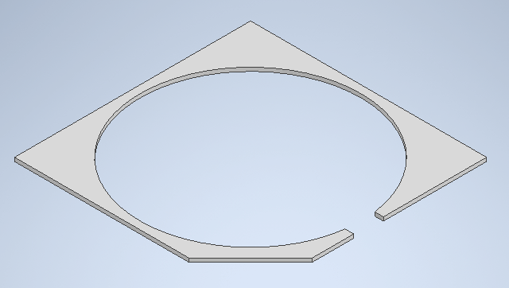 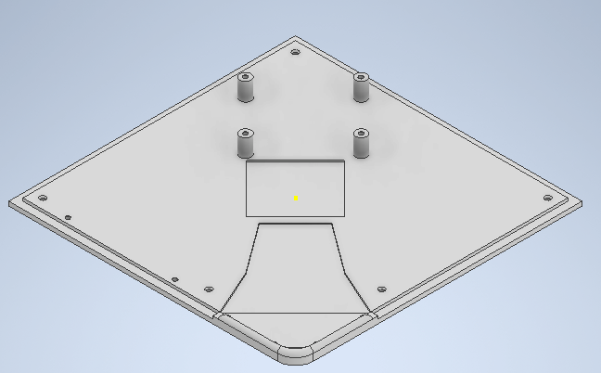

Figure 5.2.8: Top Plate, Drop Plate, and Bottom Plate

The overall housing consists of the walls (Figure 5.2.7) and baseplates (Figure 5.2.8). The wall of the design is very simple and will have a cutout to allow for power to connect to the system. The baseplates will have three components the top plate, drop plate, and baseplate. The top plate will be flush with the rotating capsule and will be visible when the lid is open. The drop plate is where the pills will be dispensed and will hold all the pills on it. It will also hold the place the servo will be used to lock the device. Finally, the baseplate is the bottom of the project and will have rubber feet to secure the device onto any surface. The two components will be connected by screws, bolts, and nuts to allow for an accurate finish.

## Software

# Testing Strategy and Results

## Electrical

## Hardware

Testing the hardware for a smart pill box is an important part of the manufacturing process. The hardware must meet certain standards to ensure the device is safe and reliable. This usually involves testing the connections of the components, checking for any potential malfunctions, and testing the overall design of the device. Additionally, the hardware must be tested for its durability and ability to withstand any potential external forces. Through these tests, we can ensure that the smart pill box is safe and reliable for its intended purpose.

Figure 6.2.1: 3D Printed Rotary Capsule

With 3D Printed parts connections always seem to be a problem. We have already tested the screw fittings, bolt fittings, and the size of the overall model. Figure 6.2.1 shows the size of the rotating capsule. The image depicts the number of pills that can fit in each slot, and it is easily over 5 pills.

Initial hardware testing we have already conducted include testing the motor torque to see if it can support the rotating capsule piece. The test was successful, and we have already learned how to increase performance. The biggest solution is to reduce the friction coefficient. This can be done by having a lighter model, ball bearings or ball rollers, and potentially a different material with a lower friction coefficient.

## Software

# Cost

## Cost Breakdown

## Parts List

# Scheduling

## Initial Schedule

## Current Schedule

# Risk Management

# Report Contributions

# References